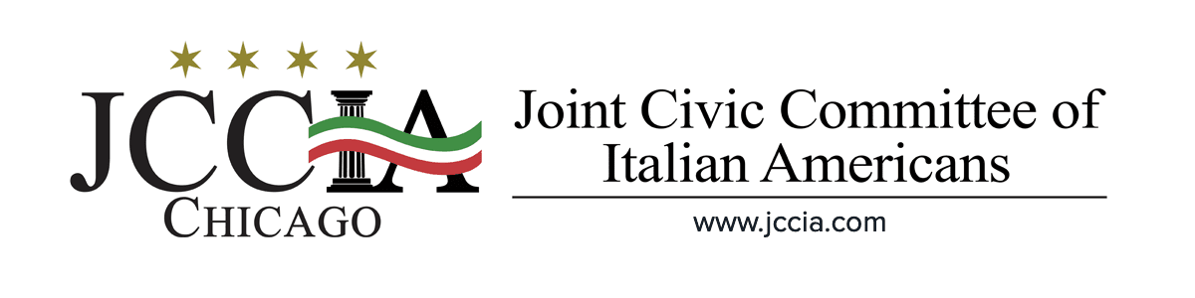
ATTENTION ITALIAN AMERICANS of COOK COUNTY:
The Joint Civic Committee of Italian Americans needs your help in saving the Columbus Day holiday in Cook County. An ordinance has been proposed that replaces Columbus Day with Indigenous People's Day. We need you to send your sentiments to YOUR Cook County Commissioner. Or simply use the letter provided in this packet.
- Please fill in the correct date and address the letter to your Cook County Commissioner found on the last page of this document and mail it to them today!
- Don’t know who your Cook County Commissioner is? Please refer to the map below and the list of corresponding commissioners to identify your Commissioner.
- Mailing letters really does help the Commissioner’s hear our concerns.
Thank you for your participation in this important campaign to preserve Columbus Day in Cook County, IL.
~Ron Onesti
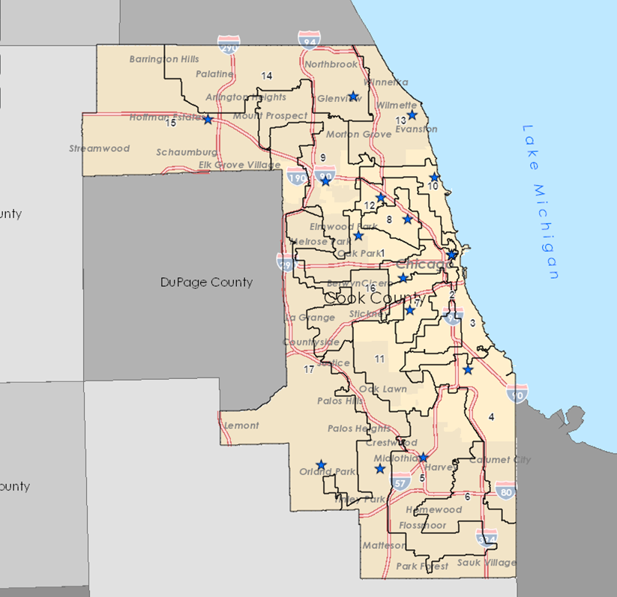
JCCIA President | president@jccia.com

Toni Preckwinkle
President of the Cook County Board of Commissioners

toni.preckwinkle@cookcountyil.gov

Commissioner Brandon Johnson
District #1
6614 W. North Avenue
Chicago, IL 60707
Phone: 312.603.4566
Fax: 312.603.3696

118 N. Clark St., Suite 567
Chicago, IL 60602
Phone: 312.603.4566
Fax: 312.603.3696

Brandon Johnson Brandon.Johnson@cookcountyil.gov
Clinee Hedspeth, Director of Legislative Affairs Clinee.Hedspeth@cookcountyil.gov
Ashlee Horton, Director of Outreach Ashlee.Horton@cookcountyil.gov
Kenyatta Land, District Director Kenyatta.Land@cookcountyil.gov
Lisa Schrantz, Executive Coordinator Lisa.Schrantz@cookcountyil.gov

Commissioner Dennis Deer
District #2
3600 W. Ogden Ave
Chicago, IL 60624
Phone: 312.603.7119
Fax: 773.722.0145

118 N. Clark St., Suite 567
Chicago, IL 60602
Phone: 312.603.3019
Fax: 312.603.4055

Dennis Deer Dennis.Deer@cookcountyil.gov
Melva Brownlee, Chief of Staff Melva.Brownlee@cookcountyil.gov
David Evers, Aide to Commissioner David.Evers@cookcountyil.gov
Nathaniel J. Gaither, Aide to Commissioner Nathaniel.Gaither@cookcountyil.gov
Shukuntla Rucker, Aide to Commissioner Shukuntla.Rucker@cookcountyil.gov

Commissioner Bill Lowry
District #3
118 N. Clark St., Suite 567
Chicago, IL 60602
Phone: 312.603.6391
Fax: 312.603.5671
Bill Lowry Bill.Lowry@cookcountyil.gov
Rosie Mandile, Executive Administrative Assistant Rosemarie.Mandile@cookcountyil.gov
Craig McLendon, District Director Craig.Mclendon@cookcountyil.gov
La ’Mont Williams, Chief of Staff LaMont.Williams@cookcountyil.gov

Commissioner Stanley Moore
District #4
8233 S. Princeton
Chicago, IL 60628
Phone: 773.783.2412

118 N. Clark St., Suite 567
Chicago, IL 60602
Phone: 312.603.2065

Stanley Moore Stanley.Moore2@cookcountyil.gov
Chetzi Canada, Manager Constituent Service Chetzi Canada@cookcountyil.gov
Warren Callahan, Chief of Staff Warren.Callahan@cookcountyil.gov
Jourdan Sorrell, Director of Public Policy & Research Jourdan.Sorrell@cookcountyil.gov
Aldine Wilson, Executive Assistant Aldine.Wilson@cookcountyil.gov

Commissioner Deborah Sims
District #5
2515 Veterans Drive
Posen, IL 60469
Phone: 708.371.4251
Fax: 708.371.4376

118 N. Clark St., Suite 567
Chicago, IL 60602
Phone: 312.603.6381
Fax: 312.603.2583

Deborah Sims Deborah.Sims@cookcountyil.gov
Aeria Charles, Chief of Staff Aeria.Charles@yahoo.com
Paulette Corner, Aide to Commissioner Paulette.Corner@cookcountyil.gov
Deborah McNeil, Aide to Commissioner Deborah.McNeil@cookcountyil.gov
Adam Moore, Aide to Commissioner Adam.Moore@cookcountyil.gov

Commissioner Donna Miller
District #6
15440 S. Central Ave
Oak Forest, IL 60452
Phone: 312.603.4216
Fax: 312.603.3693
118 N. Clark St., Suite 567
Chicago, IL 60602
Phone: 312.603.4216
Fax: 312.603.3693

Donna Miller Donna.Miller@cookcountyil.gov
Brian Ceci, Director of Policy Brian.Ceci@cookcountyil.gov
Michelle Harris, Aide to Commissioner Michelle.Harris@cookcountyil.gov
Ryan Washabaugh, Dir.of Community Affairs & Engagement Ryan.Washabaugh@cookcountyil.gov

Commissioner Alma E. Anaya
District #7
4374 S. Archer
Chicago, IL 60632
Phone: 773.376.2700
Fax: 773.376.3320

118 N. Cark St., Suite 567
Chicago, IL 60602
Phone: 312.603.5443
Fax: 312.603.3759

Alma E. Anaya Alma.Anaya@cookcountyil.gov
Jeylu Gutierrez, Aide to Commissioner Jeylu.Gutierrez@cookcountyil.go
Irene López, Aide to Commissioner Irene.López-Santoyo@cookccountyil.gov
Yesenia López, Aide to Commissioner Yesenia. López@cookcountyil.gov
Victoria Moreno, Policy Director Victoria.Moreno@cookcountyil.gov

Commissioner Luis Arroyo Jr.
District #8

2653 N. Kedzie Avenue
Chicago, IL 60647
Phone: 312.603.8530

118 N. Clark St., Suite 567
Chicago, IL 60602
Phone: 312.603.6386
Fax: 312.603.9531

Luis Arroyo Jr. Arroyojr08@gmail.com
Derrick Cabrera, Aide to Commissioner Derrick.Cabrea@cookcountyil.gov
Nancy Gonzalez, Aide to Commissioner Nancy.Gonzalez@cookcountyil.gov
Cristina Saldana, Aide to Commissioner Cristina.Saldana@cookcountyil.gov
Rudy Urian, Chief of Staff Rudyard.Urian@cookcountyil.gov

Commissioner Peter N. Silvestri
District #9
5515 N. East River Road
Chicago, IL 60656
Phone: 773.444.0346
Fax: 773.444.0373
118 N. Clark St., Suite 567
Chicago, IL 60602
Phone: 312.603.4393
Fax: 312.603.1154

Peter N. Silvestri cookcty9@aol.com
Mary Beth Hoerner, Communications Specialist Marybeth.Hoerner@cookcountyil.gov
Alicia Jakymiw, Community Outreach Alicia.Jakymiw@cookcountyil.gov
Maureen McPartland, Community Liaison Maureen.McPartland@cookcountyil.gov
Diane Viverito, Chief of Staff Diane.Viverito@cookcountyil.gov

Commissioner Bridget Gainer
District #10
5533 N. Broadway Avenue
Chicago, IL 60640
Phone: 773.561.1010

118 N. Clark St., Suite 567
Chicago, IL 60602
Phone: 312.603.4210
Fax: 312.603.3695

Bridget Gainer Bridget.Gainer@cookcountyil.gov
Isabel Dobbel, Legislative Affairs District10@cookcountyil.gov
Shantenae Robinson, Chief of Staff Shantenae.Robinson@cookcountyil.gov
Lindsey Winters, Administrative Office Manager Lindsey.Winters@cookcountyil.gov
Noureen Hashim, Policy & Communications Coord Noureen.Hasim@cookcountyil.gov

Commissioner John P. Daley
District #11
118 N. Clark St., Floor 3½
Chicago, IL 60602
Phone: 312.603.4400
Fax: 312.603.6688

John P. Daley John.Daley@cookcountyil.gov
Bridget Botica, Aide to Commissioner Bridget.Botica@cookcountyil.gov
Anthony Scalise, Chief of Staff Anthony.Scalise@cookcountyil.gov

Commissioner Bridget Degnen
District #12
4253 N Milwaukee Ave.
Chicago, IL 60641
Phone:773-283-7873

118 N. Clark St., Suite 567
Chicago, IL 60602
Phone: 312.603.6380
Fax: 312.603.1265

Bridget Degnen Bridget.Degnen@cookcountyil.gov
Salma Ghayloun, Constituent Outreach Representative Salma.Ghayloun@cookcountyil.gov
Rebecca Horrighs, Constituent Outreach Coordinator Rebecca.Horrighs@cookcountyil.gov
Tara Meyer, Chief of Staff & General Counsel Tara.Meyer@cookcountyil.gov
Lori Probasco, Legislative Director Lori.Probasco@cookcountyil.gov

Commissioner Larry Suffredin
District #13
2510 Green Bay Road,
Evanston, IL 60201
Phone: 847.864.1209
Fax: 847.864.1445

118 N. Clark St., Suite 567
Chicago, IL 60602
Phone: 312.603.6383
Fax: 312.603.3622

Larry Suffredin Lsuffredin@aol.com
Cicely Fleming, Assistant District Director Cfleming@suffredin.org
Michelle Jordan, General Counsel & District Director Mjordan@suffredin.org
Mary Rita Luecke, General Counsel Mrluecke@suffredin.org
Adam Newman, Chief of Staff Anewman@suffredin.org

Commissioner Scott R. Britton
District #14
1812 Waukegan Rd., Suite C
Glenview, IL 60025
Phone: 847.729.9300
Fax: 847.729.2279

118 N. Clark St., Suite 567
Chicago, IL 60602
Phone: 312.603.4932
Fax: 312.603.3686

Scott R. Britton Scott.Britton@cookcountyil.gov
Julie Kaviar, Chief of Staff Julie.Kaviar@cookcountyil.gov
Liz Polmanski, Deputy Chief of Staff Liz.Polmanski@cookcountyil.gov

Commissioner Kevin B. Morrison
District #15
1325 Wiley Road, Suite 141
Schaumburg, IL 60173
Phone: 847-519-7674

118 N. Clark St., Suite 567
Chicago, IL 60602
Phone: 312.603.6388
Fax: 312.603.6500

Kevin B. Morrison Kevin.Morrison@cookcountyil.gov
Jessica Beezhold, Constituent Services Liaison Jessica.Beezhold@cookcountyil.gov
Justin Koziatek, Constituent Services Liaison Justin.Koziatek@cookcountyil.gov
Ted Mason, Chief of Staff Theodore.Mason@cookcountyil.gov
Caitlin McElroy, Legislative Director Caitlin.McElroy@cookcountyil.gov

Commissioner Frank J. Aguilar
District #16
7833 Ogden,
Lyons, IL 60534
Phone:
Fax:

118 N. Clark St., Floor 3½
Chicago, IL 60602
Phone: 312.603.4735
Fax: 312.603.4744

Frank Aguilar Frank.Aguilar@cookcountyil.gov
Michilla Blaise, Chief of Staff Michilla.Blaise@cookcountyil.gov
Gillian DeLeon, Aide to Commissioner Gillian.Deleon@cookcountyil.gov
Cecilia Camacho-Salinas, Aide to Commissioner Cecilia Salinas@cookcountyil.gov
Tanisha Shelby-Woodson Aide to CommissionerTanisha.Shelby-Woodson@cookcountyil.gov

Commissioner Sean M. Morrison
District #17
15040 Ravinia Ave. Suite #44
Orland Park, IL 60462
Phone: 708.349.1336
Fax: 708.349.1627

118 N. Clark St., Suite 567
Chicago, IL 60602
Phone: 312.603.4215
Fax: 312.603.2014
Sean M. Morrison Sean.Morrison@cookcountyil.gov
Kathy Hilton, Constituent Services Coordinator Kathy.Hilton@cookcountyil.gov
Jennifer O’Flaherty, Deputy Chief of Staff Jennifer.oflaherty2@cookcountyil.gov
Christopher Provenzano, Chief of Staff Christopher.Provenzano@cookcountyil.gov

*****

The last page of this document is the letter we need you to fill out, sign and mail to your Cook County Commissioner. If you can edit this document, please fill in the date, add the Commissioner’s full name, District # and address below the date, and address the letter to “Commissioner ____(last name)”. Finally, please sign your full name and provide your mailing address to the letter and/or the envelope.

Thank you!
Ron Onesti
JCCIA President
president@jccia.com

May __, 2021

Dear Commissioner _________
I live in your district and I am concerned about Resolution 21-0565, which seeks to replace Columbus Day with Indigenous People’s Day. I am opposed to passage of this resolution.
I firmly believe in the celebration of ones’ cultural heritage, but not at the expense of another. There are already four separate dates and occasions that celebrate Indigenous People on the local and national level, therefore, confiscating Columbus Day is not fair, nor acceptable.
Former Governor Bruce Rauner signed into law Indigenous People’s Day which is celebrated on the last Monday in September. There is also National and International Indigenous People’s Day, and Native American History Month in November. I fail to see where another day of celebration is warranted by taking away the ONLY day Italian Americans have.
I am proud of my heritage and would never tell anyone else how to celebrate it or whom they should celebrate.
I appreciate your time and once again encourage you to vote no to passage of this unfair resolution.

Sincerely,

